
lab mid
Web Technology


Submitted by:-
Aftab Akram
Registration no:-
FA24-BSE-060
Submitted to:-
Mam Yasmeen Jana

Screenshot:
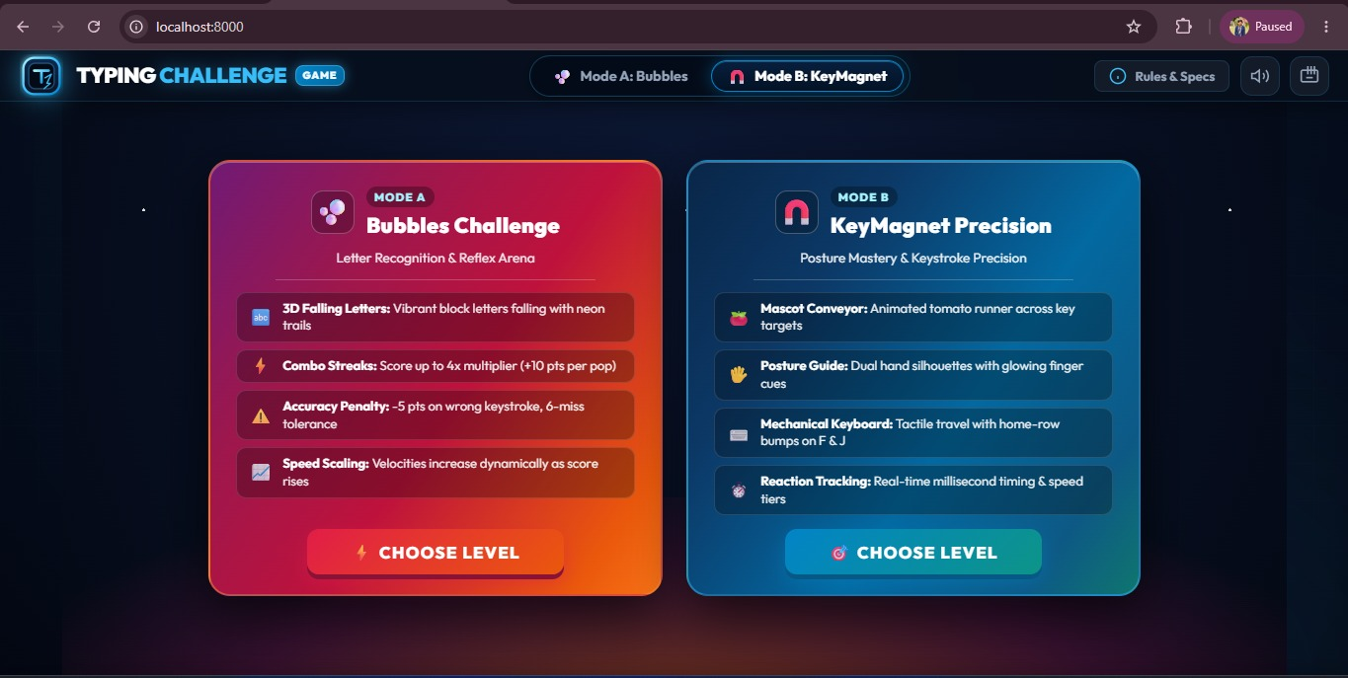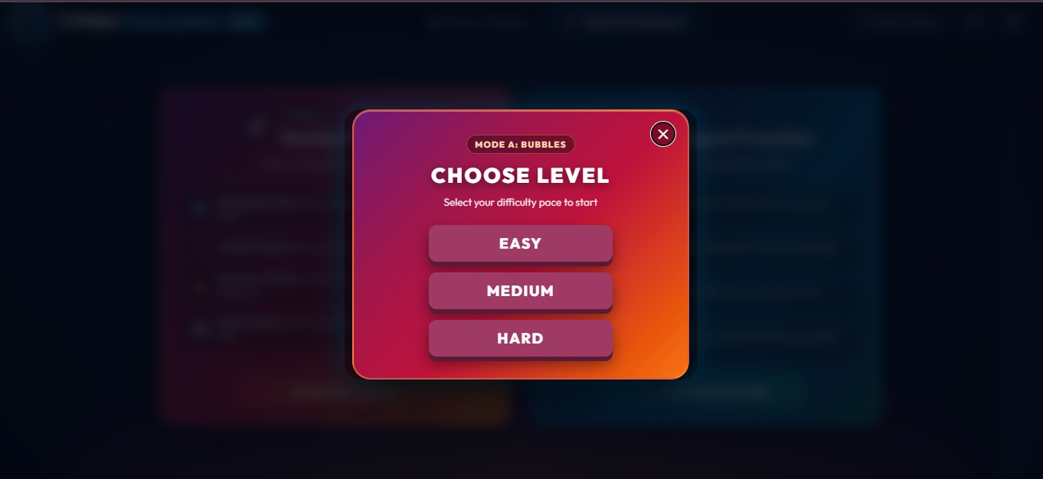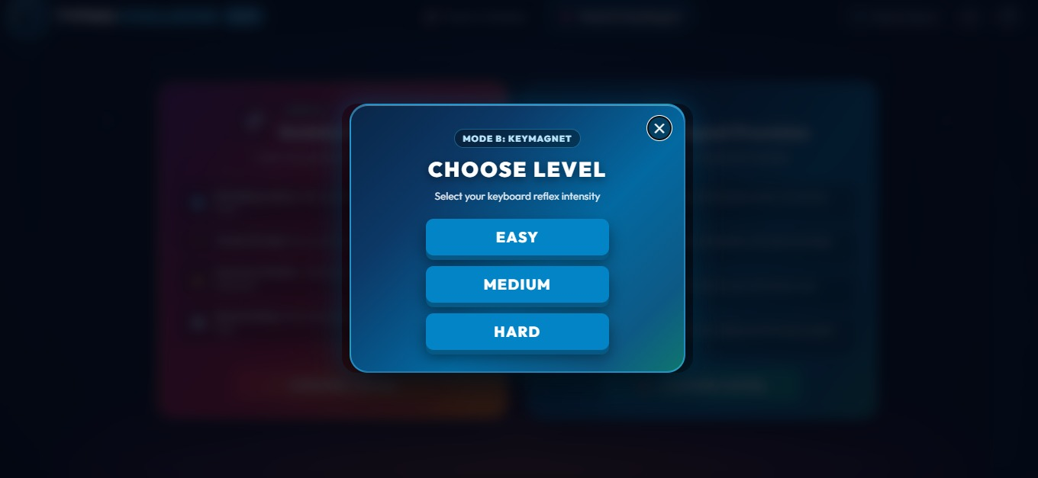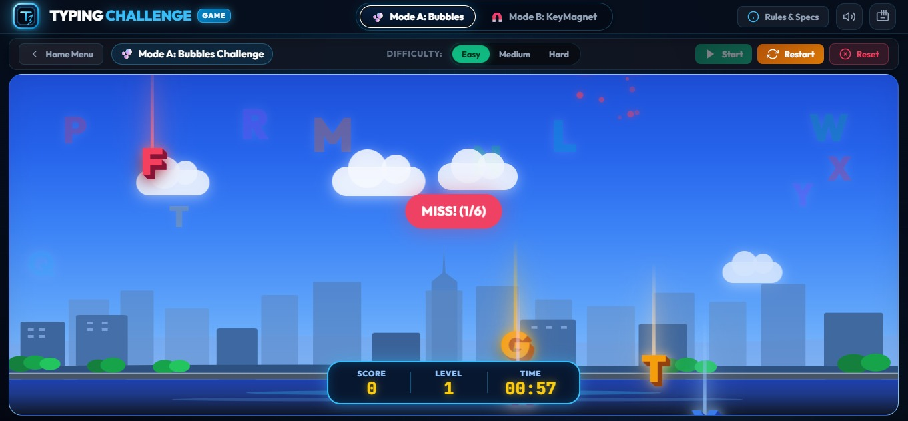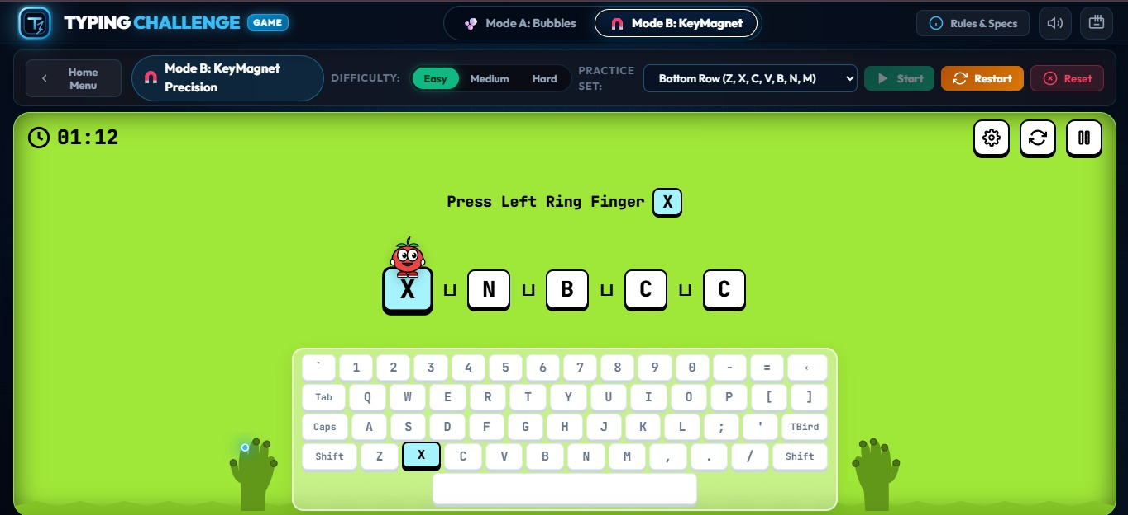

Link:
https://github.com/Aftab272/Web-Development-5th-Semester/commit/97b5a2d7081e5204f47d6fca853f94d6f48a33a5

